LOW CODE
EXPERIMENT-2

NAME: MOHAN PRASATH P ROLL NO: 240701328
Aim: To create a sample application in Zoho Creator, create a form, report, and dashboard, and explore the Develop, Deploy, and Manage sections of the Zoho Creator platform.

Setting up Zoho Creator:

- Create the Sample Application Procedure:

  - Logged in to Zoho Creator.

  - Clicked Create New Application.

  - Selected From scratch.

  - Entered the application name as "Inventory Management Form".

  - Clicked Create Application.

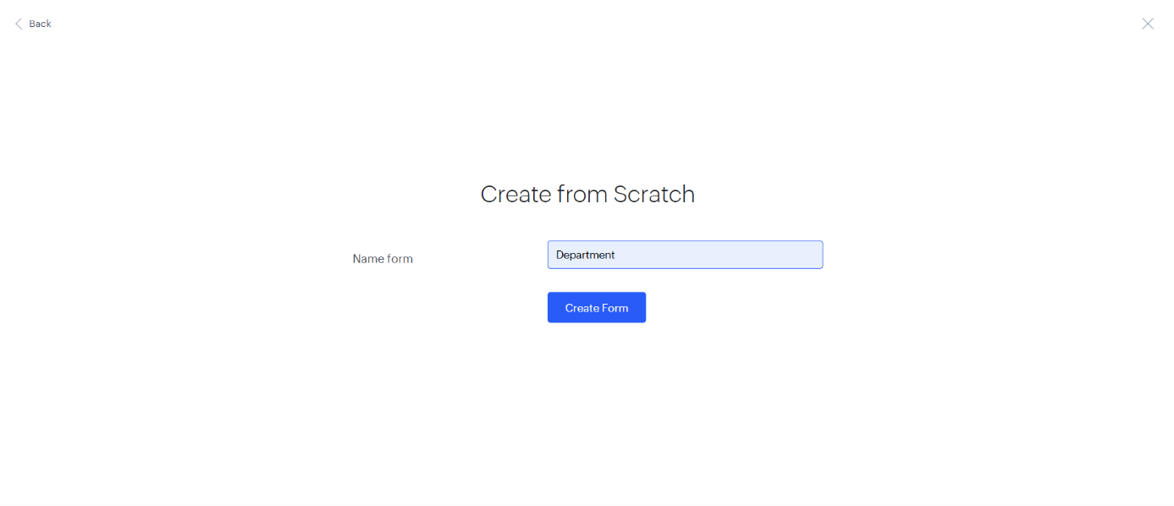

Creating Form Procedure:

  - Clicked Create → Form.

  - Entered the form name as "Inventory Details".

  - Added the required fields such as Item Name, Item Serial Number, Item Description, Item Storing Date, and Item state.

  - Saved the form.

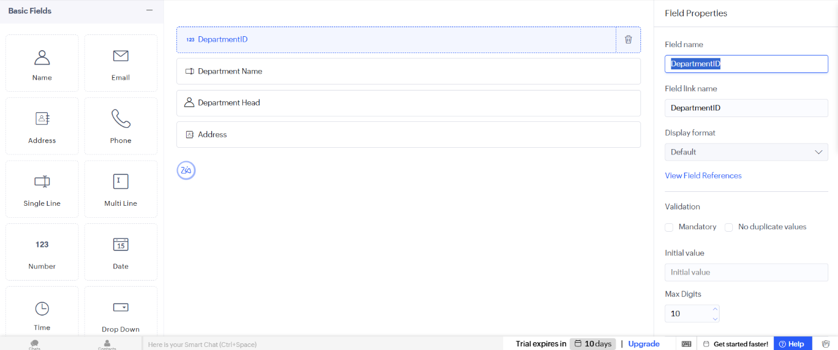

Explanation: A form is used to collect information from users. It contains various input fields where users can enter data. The submitted data is stored in the application's database.

Viewing the Live Form Procedure:

  - Opened the live "Inventory Details" form to input data.

  - Entered sample records (e.g., Laptop, Lenovo Yoga...)

  - Saved the entered data.

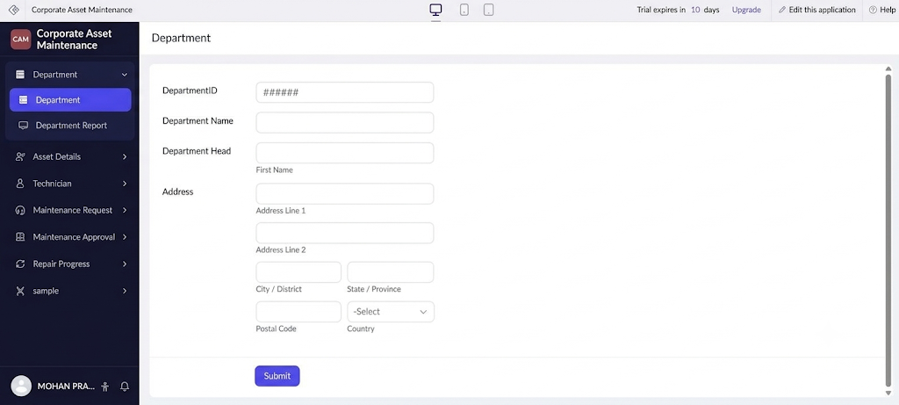

Creating Report Procedure:

  - Clicked Create → Report.

  - Selected the Inventory Details form to generate the "All Inventory Details" report.

  - Created the report and saved it.

Explanation: A report displays all the records entered through the form. It helps users search, sort, filter, and manage the stored data efficiently.

Exploring the Platform Architecture and Interface:

- Develop:
The Develop section is used to build applications. It allows users to create forms, reports, pages, and workflows. It also supports application customization using Deluge scripting.

Deploy:
The Deploy section is used to publish applications. It allows sharing applications with users securely. User roles and permissions can also be configured here.

Manage:
The Manage section is used to administer the application. It helps manage users, backups, and integrations. It also monitors application performance and security.

Result:
Thus, a Zoho Creator account was created successfully. A sample application with a form,
report, and dashboard was developed, and the Develop, Deploy, and Manage sections of the Zoho Creator platform were explored successfully.

